|  |  |
| --- | --- |
| Activity | Data Type |
| Number of beatings from Wife | Discrete data type |
| Results of rolling a dice | Discrete data type |
| Weight of a person | Continuous data type |
| Weight of Gold | Continuous data type |
| Distance between two places | Continuous data type |
| Length of a leaf | Continuous data type |
| Dog's weight | Continuous data type |
| Blue Color | Discrete data type |
| Number of kids | Discrete data type |
| Number of tickets in Indian railways | Discrete data type |
| Number of times married | Discrete data type |
| Gender (Male or Female) | Discrete data type |

Q1) Identify the Data type for the Following:

Q2) Identify the Data types, which were among the following

Nominal, Ordinal, Interval, Ratio.

|  |  |
| --- | --- |
| Data | Data Type |
| Gender | Nominal |
| High School Class Ranking | Interval |
| Celsius Temperature | Interval |
| Weight | Ratio |
| Hair Color | Nominal |
| Socioeconomic Status | Ordinal |
| Fahrenheit Temperature | Interval |
| Height | Ratio |
| Type of living accommodation | Ordinal |
| Level of Agreement | Ordinal |
| IQ(Intelligence Scale) | Ratio |
| Sales Figures | Ratio |
| Blood Group | Nominal |
| Time Of Day | Interval |
| Time on a Clock with Hands | Interval |
| Number of Children | Nominal |
| Religious Preference | Nominal |
| Barometer Pressure | Interval |
| SAT Scores | Interval |
| Years of Education | Interval |

Q3) Three Coins are tossed, find the probability that two heads and one tail are obtained?

Ans -3/8

Q4) Two Dice are rolled, find the probability that sum is

1. Equal to 1 = 0
2. Less than or equal to 4= 6/36= 1/6
3. Sum is divisible by 2 and 3 6/36 = 1/6

Q5) A bag contains 2 red, 3 green and 2 blue balls. Two balls are drawn at random. What is the probability that none of the balls drawn is blue?

7c2 = 21 ways of drawing balls 7*6/2=21 ways

First ball is drawn (except blue balls ) 5/7

Second ball is drawn ball reduced to 4/6 = 2/3

Thus probability non blue ball is drawn is 5/7 * 2/3 = 10/21

Q6) Calculate the Expected number of candies for a randomly selected child

Below are the probabilities of count of candies for children (ignoring the nature of the child-Generalized view)

|  |  |  |
| --- | --- | --- |
| CHILD | Candies count | Probability |
| A | 1 | 0.015 |
| B | 4 | 0.20 |
| C | 3 | 0.65 |
| D | 5 | 0.005 |
| E | 6 | 0.01 |
| F | 2 | 0.120 |

Child A – probability of having 1 candy = 0.015.

Child B – probability of having 4 candies = 0.20

(1*0.015)+(4*0.20)+(3*0.65)+(5*0.005)+(6*0.01)+(2*0.120) =3.225

Q7) Calculate Mean, Median, Mode, Variance, Standard Deviation, Range & comment about the values / draw inferences, for the given dataset

* For Points,Score,Weigh>

Find Mean, Median, Mode, Variance, Standard Deviation, and Range and also Comment about the values/ Draw some inferences.

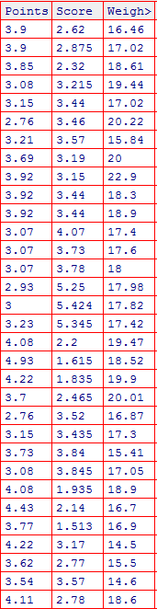

|  |
| --- |
| No7  > mean(Given_data$Points)  [1] 3.596563  > mean(Given_data$Scores)  [1] 3.203187  > mean(Given_data$Weights)  [1] 17.8425  > median(Given_data$Points)  [1] 3.695  > median(Given_data$Scores)  [1] 3.325  > median(Given_data$Weights)  [1] 17.71  > mode(Given_data$Points)  [1] 1  > mode(Given_data$Scores)  [45] 60  > mode(Given_data$Weights)  [710] 178  > sd(Given_data$Points)  [1] 0.5346787  > sd(Given_data$Scores)  [1] 1.005099  > sd(Given_data$Weights)  [1] 1.790714  >  > range(Given_data$Points)  [1] 2.76 4.93  > range(Given_data$Scores)  [1] 1.165 5.424  > range(Given_data$Weights)  [1] 14.5 22.9  > var(Given_data$Points)  [1] 0.2858814  > var(Given_data$Scores)  [1] 1.010224  > var(Given_data$Weights)  [1] 3.206658 |
|  |
| |  | | --- | | > | |

Q8) Calculate Expected Value for the problem below

1. The weights (X) of patients at a clinic (in pounds), are

108, 110, 123, 134, 135, 145, 167, 187, 199

Assume one of the patients is chosen at random. What is the Expected Value of the Weight of that patient?

Ans – EV = ∑X/n= 1308 /9 = 145.33333

Q9) Look at the data given below. Plot the data, find the outliers and find out $μ, σ, σ^{2}$

|  |  |
| --- | --- |
| **Name of company** | **Measure X** |
| Allied Signal | 24.23% |
| Bankers Trust | 25.53% |
| General Mills | 25.41% |
| ITT Industries | 24.14% |
| J.P.Morgan & Co. | 29.62% |
| Lehman Brothers | 28.25% |
| Marriott | 25.81% |
| MCI | 24.39% |
| Merrill Lynch | 40.26% |
| Microsoft | 32.95% |
| Morgan Stanley | 91.36% |
| Sun Microsystems | 25.99% |
| Travelers | 39.42% |
| US Airways | 26.71% |
| Warner-Lambert | 35.00% |

|  |
| --- |
| #Question no 9  > mean(x$Measure.X)  [1] 33.27133  > var(x$Measure.X)  [1] 287.1466  > sd(x$Measure.X)  [1] 16.9454  > #Boxplot  > boxplot(x$Measure.X, horizental =TRUE) |

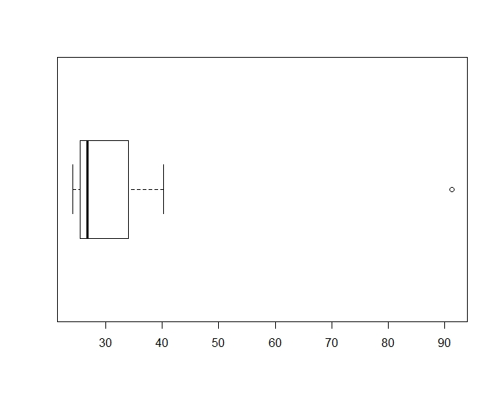

Q10) AT&T was running commercials in 1990 aimed at luring back customers who had switched to one of the other long-distance phone service providers. One such commercial shows a businessman trying to reach Phoenix and mistakenly getting Fiji, where a half-naked native on a beach responds incomprehensibly in Polynesian. When asked about this advertisement, AT&T admitted that the portrayed incident did not actually take place but added that this was an enactment of something that “could happen.” Suppose that one in 200 long-distance telephone calls is misdirected. What is the probability that at least one in five attempted telephone calls reaches the wrong number? (Assume independence of attempts.)

Probability of one wrong number = 1 /200

Probability of remaining misdirected calls = 1 – 1/200 = 199/200 =

Probability of at least one in every 5 = 5 * 200/199 / 1/200 *100 = 2.52%

Q11) Returns on a certain business venture, to the nearest $1,000, are known to follow the following probability distribution

|  |  |
| --- | --- |
| X | P(x) |
| -2,000 | 0.1 |
| -1,000 | 0.1 |
| 0 | 0.2 |
| 1000 | 0.2 |
| 2000 | 0.3 |
| 3000 | 0.1 |

1. What is the most likely monetary outcome of the business venture?

Ans -The most likely highest return is $2000 as its probability is 0.3 = getting return 600$

1. Is the venture likely to be successful? Explain

Ans -We can take into positive probability value(positive return) to measure success of this venture (0.2+0.3+0.1) = 0.6 ( take 0.1 as 10%)

Probability of getting return is 60% chance it is a successful one

1. What is the long-term average earning of business ventures of this kind? Explain

Ans - Long term average earning potential considers both positive and negative returns = ( -2000* 0.1 + -1000*0.1 +0 *0.2 * 1000*0.2+2000*0.3+3000*0.1) = -300+1100 = 800

1. What is the good measure of the risk involved in a venture of this kind? Compute this measure

Ans – To measure the risk involved in this venture we again have to find out the point of variation from the mean, SD and variation or dispersion from Standard deviation